PHASE III: REQUIREMENT ANALYSIS
Date | 06 November 2025
Team ID | NM2025TMID08793
Project Name | Lease Management
Maximum Marks | 4 Marks

Title: Requirement Analysis for “Lease Management”

1. Objective
The Requirement Analysis Phase focuses on identifying, defining, and validating the functional and technical requirements needed to develop the Lease Management application on the Salesforce platform.
This document ensures clarity of scope, system behaviour, data structure, automation needs, and performance expectations, providing a strong foundation for system design and implementation.

2. Scope of the System
The Lease Management system is designed to digitize and automate end-to-end lease agreement processes between property owners and tenants.
The scope includes:
- Digital lease document storage & tenant onboarding
- Automated rent reminders & lease renewal alerts
- Payment tracking and overdue alerts
- Dashboard & report-based analytics
- Secure, role-based access for Owner, Tenant & Admin

3. Functional Requirements

3.1 Core Functional Modules
Module | Functionality | Salesforce Feature Used
Property Management | Register properties & unit details | Custom Object
Tenant Management | Store tenant details & lease info | Custom Object + Flow
Lease Agreement  Handling | Create, upload & track lease documents | File Upload + Lookup
Rent Reminder System | Auto-reminds tenants of due dates | Flow + Email Alert
Payment Tracking | Records paid, pending & overdue rents | Custom Object + Reports
Renewal & Expiry Alerts | Alerts owner & tenant before lease expiry | Scheduled Flow
Dashboard Analytics | Tracks total rent, pending rent, expiring leases | Reports + Dashboards

3.2 System Workflow (Process Flow)
- Owner/Agent adds property and tenant details.
- Lease record is created with start date, end date, and rent value.
- System auto-schedules monthly rent reminder emails/SMS.
- Tenant updates payment status or admin logs payment.
- Dashboard updates real-time rent collection status.
- System alerts both parties 30 days before lease expiry.

4. Technical Requirements

Category | Requirement | Description
Platform | Salesforce Developer Edition | CRM cloud for automation
Programming | Apex (if needed) | Auto constraints & validation
Automation | Salesforce Flow | Auto rent reminder & renewal alerts
Database | Salesforce Objects | Property, Tenant, Lease, Payment
Visualization | Dashboard Builder | Rent status, lease expiry chart
Security | Profiles & Roles | Owner, Tenant, Admin access control

4.1 Software Tools Used
- Salesforce Lightning Experience
- Flow Builder
- Schema Builder
- Reports & Dashboards
- Developer Console

4.2 Hardware Requirements

Component | Minimum Requirement
Processor | Intel i3 or above
RAM | 4 GB+
Internet | Min 2 Mbps stable
Storage | 500 MB browser cache
Browser | Chrome / Edge latest

5. Non-Functional Requirements
Category | Requirement | Description
Performance | System must support 200+ active leases | Handled via Salesforce architecture
Security | Role-based access | Tenants cannot see other tenant data
Usability | Simple UI for non-technical users | Lightning App Navigation
Scalability | Should support multi-property owners | Object relationships dynamic
Reliability | 99.9% uptime | Salesforce cloud standards
Maintainability | Low-code updates | Flow-based automation

7. Data Model Design

Object | Key Fields | Relationship Type
Property | Name, Location, Unit Count | Lookup to Owner
Tenant | Name, Phone, Email | Lookup to Property
Lease Agreement | Start Date, End Date, Rent Amount | Master-Detail (Tenant)
Payment | Month, Amount, Status, Date | Master-Detail (Lease Agreement)
Reminder Log | Reminder Date, Type | Lookup to Lease

Example Formula Field (Lease Duration):
End_Date__c - Start_Date__c
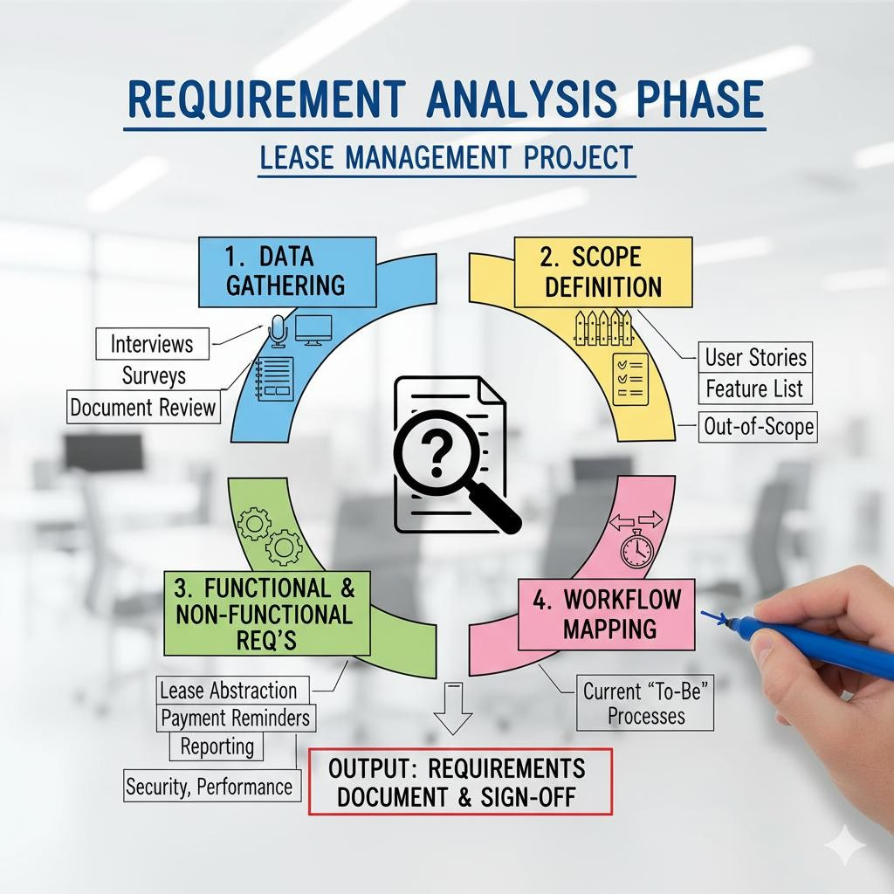

7. User Interface (UI) Requirements
Navigation tabs inside Salesforce Lightning App:
- Properties
- Tenants
- Lease Agreements
- Payments
- Dashboards

7.1 UI Expectations
- One-click create Lease Agreement with auto-calculated fields
- Mobile-friendly layout for tenants
- Dashboard embedded in Home Page
- Auto status indicators: Paid, Pending, Overdue

8. System Validation Requirements
Test Area | Description | Expected Result
Flow Execution | Auto-rent reminder every month | Email/SMS triggered
Lease Expiry Alert | 30-day before alert | Notification to Owner & Tenant
Dashboard | Payment & lease summary | Auto refresh with latest data
Permission Test | Tenant access control | Tenant sees only own record

9. Risk Identification & Mitigation
Risk | Description | Mitigation
Data Loss | Lease docs deleted accidentally | Enable recycle bin & backup
Wrong Access | Tenants viewing other data | Profile-based object rules
Payment Disputes | No proof of payment | Add Receipt Upload & Log
Automation Failure | Flow errors | Add Debug logs + Test class

10. Summary
The Requirement Analysis Phase establishes a complete blueprint for the Lease Management point. It documents the functional, technical, data, and validation needs, ensuring smooth development in the upcoming design phase.
Key achievements of this phase:

- Defined all core modules & workflows
- Mapped data model & object relationships
- Established UI layout & automation logic
- Identified risks and mitigation plans
This phase ensures the Lease Management project is clear, structured, scalable, and implementationready.

